**Using Amazon S3 Server with Cyberduck**

**Purpose:**

Use Cyberduck to easily load and organize your content on YM Learning’s Amazon Content Server. While we do not officially endorse or support any particular FTP client and cannot guarantee performance, Cyberduck is one that we make frequent use of and have had success with.

**NOTE:** Different file types will need to use different URL formats for functionality or performance optimization.

**Process:**

1. Access your server folder and upload your content.
2. Determine what type of content you are working with, and format the URL correctly.

**To upload files and folders to the Amazon server:**

1. Download and Install Cyberduck: <https://cyberduck.io/?l=en>
2. 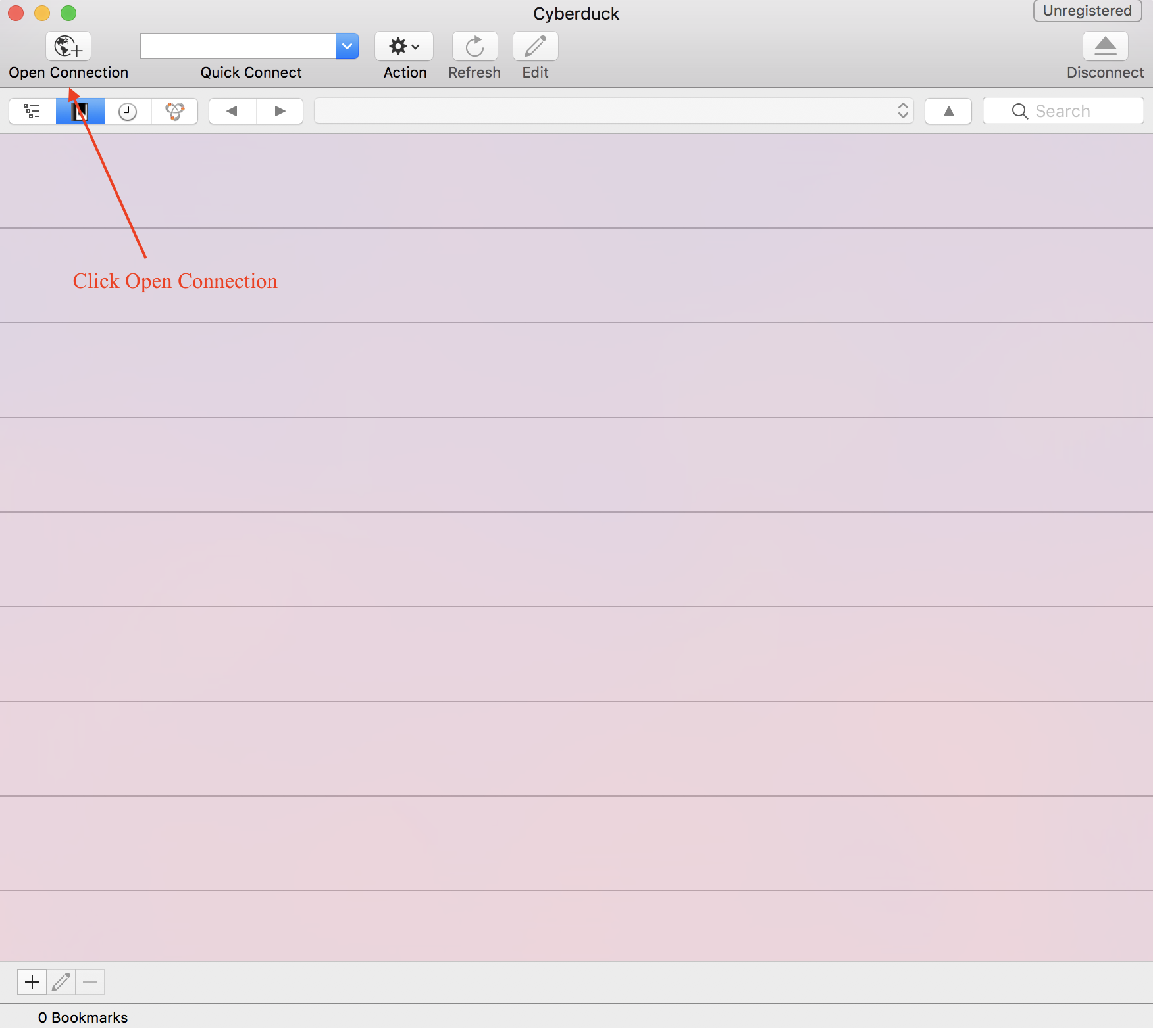Open Cyberduck and click Open Connection.
3. Add your username and secret access key.

* 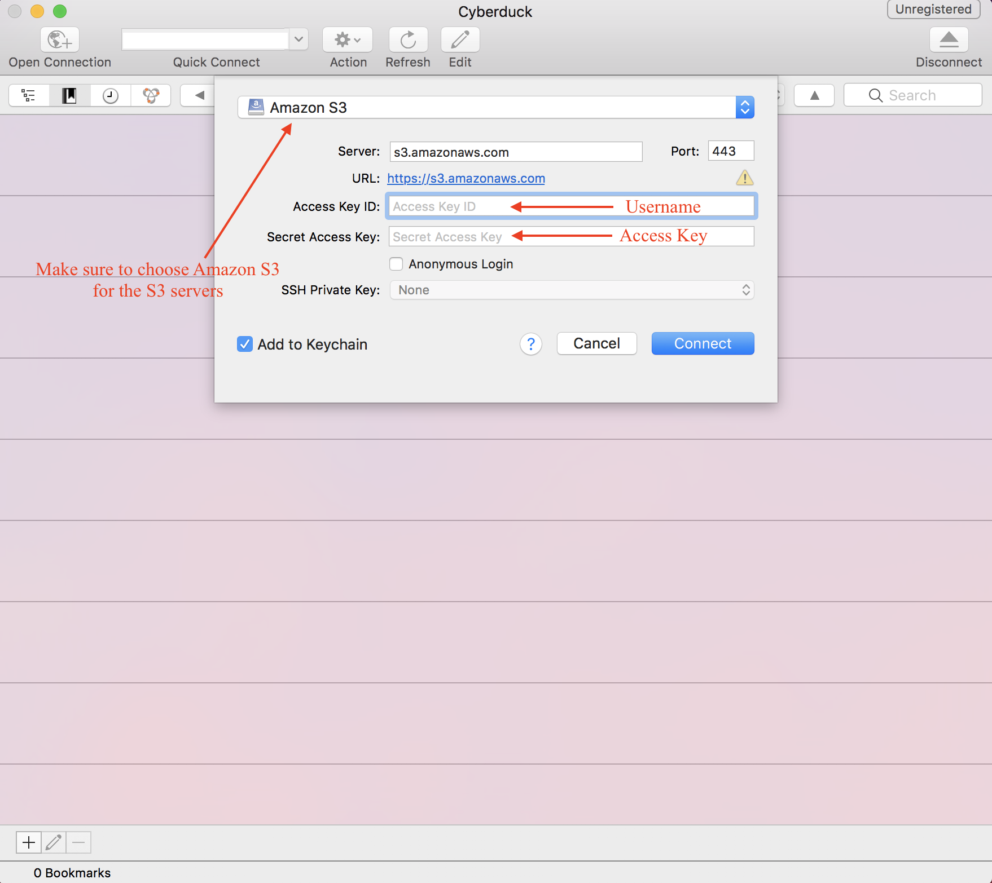

1. Press Connect (click “continue”). Once you have connected, there is a last step needed to access your files.
2. A bookmark will need to be created with your file path to allow access to your folder. file path: (e.g. “media.mycrowdwisdom.com/demo”, replace demo with your account’s acronym. **NOTE**: this is **case sensitive**)

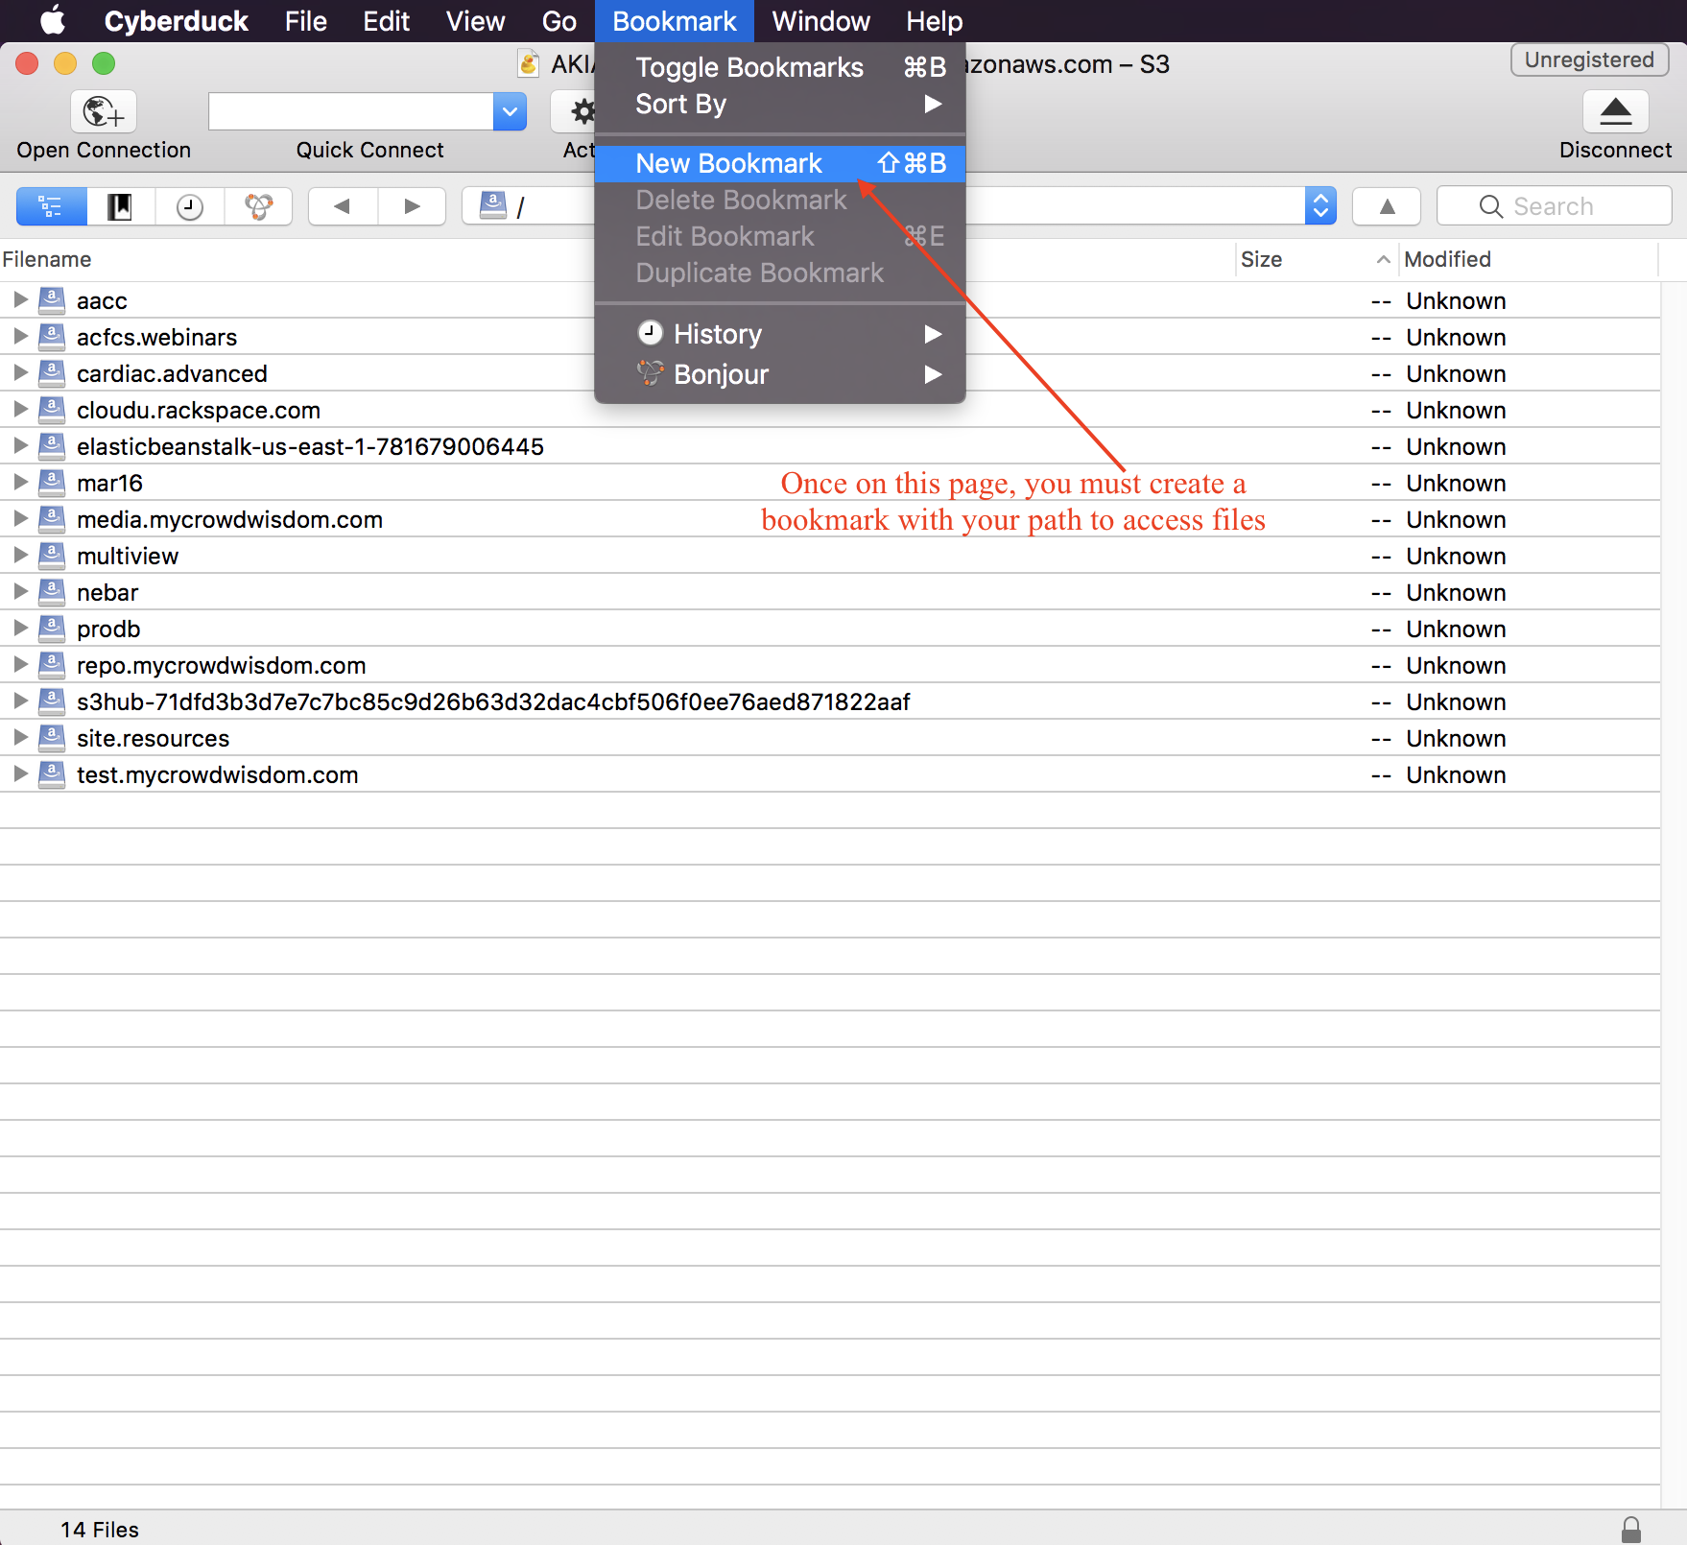

1. Once you have clicked New Bookmark, you will be greeted with a last popup that will need to be filled out.

* 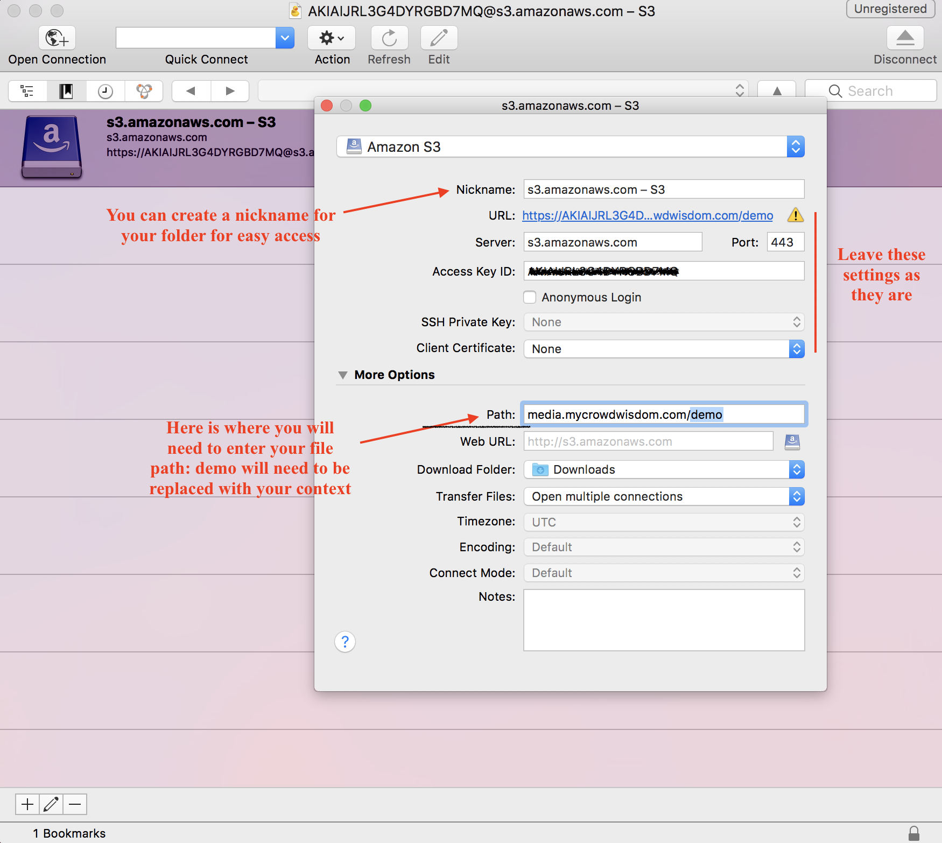

1. After this stage, you should be all set to access the files in your folder. You will no longer need to enter your access ID and access Key every time you enter. Your folder will be saved under bookmarks in Cyberduck.
2. Add your files by dragging and dropping or right-clicking and selecting. Add folders by right clicking and selecting Add Folder.
3. Right click on items you’d like to link to the LMS and select Copy URL. Select the http URL (NOT https, https will not work), and paste it into the Launch URL field in the desired product.

**Uploading Items to Amazon**

1. After following the steps to access amazon click on the folder you would like to upload to. If you would like to create a new folder, simply right click and name a file.
2. To upload items to amazon you can either right click and select the upload option to browse your computer, or open your destination folder, and drag/drop items in. You may receive a certificate error, press continue to complete the upload.

* To reference the files you have just uploaded, right click on the file and click the “copy url” option. This will expand the window to include a number of url options, http is the most common and should be used unless otherwise needed.